Native Americans and Blood Quantum
(Lesson 14)
Solution Key and Teacher’s Guide

ACTIVITY #1 – Native American Population

Research the following tribes’ current enrollments.

SOLUTION: The U.S. Census Bureau uses self-reported Indian identity data as opposed to actual tribal enrollment figures, so that would not be an advisable source for accurate statistics for this table. The BIA does not internally keep a list of tribal numbers either. Students will probably have the best success looking on individual tribes’ websites for the most current information on population of enrolled members. The numbers in the table below were found at the following websites:

White Mountain Apache - http://www.wmat.nsn.us/history.html

Nez Perce - http://www.critfc.org/member_tribes_overview/nez-perce-tribe/

Comanche - http://www.comanchenation.com/

Kaw Nation - http://kawnation.com/?page_id=72

Degree blood quantum required for membership | Tribe | Current population of enrolled members
 | White Mountain Apache | ≈ 15,000
 | Nez Perce | ≈ 3500
 | Comanche | 15,191
 | Eastern Band Cherokee | 13,000+
 | Kaw Nation | 3376

ACTIVITY #2 – Blood Quantum Fractions

Scenario: If your great-great-grandfather was the chief of x tribe (full-blooded) and your mother was ½ b tribe, ¼ c tribe, and ¼ x tribe, what would your percent be based on this information?

Use this Blood Quantum Chart to determine your quantum.

How would you set up this problem?

SOLUTION: Based on the given information, one can calculate blood quantum for the (1) x tribe, the (2) b tribe, or the (3) c tribe. Let’s look at each possibility below.

(1) x tribe – There are two possible scenarios for calculating blood quantum for x tribe:

Scenario 1: Your mother is the descendant of your great-great-grandfather (full-blooded chief of x tribe).

In this case, you will receive half of your blood from your mother, who is ¼ x tribe,

{x tribe blood quantum from your mother}

and the other half from your father. With no given information about your father, it is possible that he has anywhere from 0% to 100% x tribe blood. Using these two extremes, we can calculate the range of possible values of x tribe blood quantum. If he has 0% x tribe blood, you will receive half of that from your father.

{x tribe blood quantum from your father – least possible}

On the other hand, if your father has 100% x tribe blood, you will receive half of that.

{x tribe blood quantum from your father – greatest possible}

Adding half of your mother’s x tribe blood with half of your father’s x tribe blood, we get the two possible extremes:

{least possible blood quantum}

{greatest possible blood quantum}

So, depending on your father’s x tribe blood quantum, you will have anywhere from

to x tribe blood quantum.

To use the chart to determine your blood quantum for this scenario, locate your mother’s blood quantum on the far left column. Next, locate your father’s two possible extremes along the top row. See the example below and you will discover the same two results as stated above.
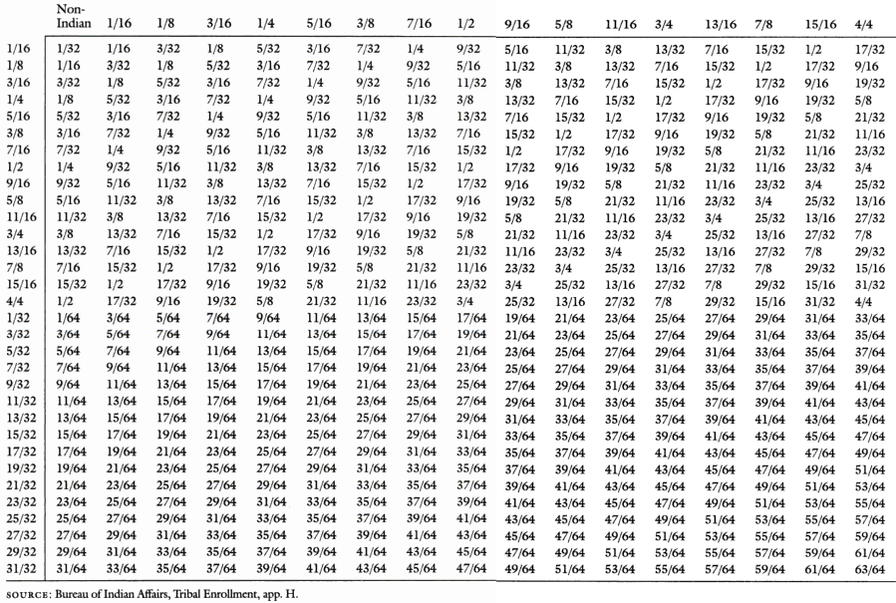

Scenario 2: Your father is the descendant of your great-great-grandfather (full-blooded chief of x tribe).

In this case, you will again receive half of your blood from your mother, who is ¼ x tribe,

{x tribe blood quantum from your mother}

and the other half from your father. However, in this case the least x tribe blood quantum your father could possibly have is . That would occur if no other parent in the lineage had any x tribe blood. Your great-great-grandfather would have 100% x tribe blood quantum. Your great-grandparent (his child) would have ½ x tribe blood quantum. That person’s child (your grandparent) would have ¼ x tribe blood quantum, and that person’s son (your father) would have x tribe blood quantum. In this case, you would have half of your father’s x tribe blood quantum.

{x tribe blood quantum from your father – least possible}

The other extreme would be if every parent in the lineage was full-blooded x tribe. In this case, your father would have 100% x tribe blood quantum, and you would have half his x tribe blood quantum.

{x tribe blood quantum from your father – greatest possible}
Adding half of your mother’s x tribe blood with half of your father’s x tribe blood, we get the two possible extremes:

{least possible blood quantum}

{greatest possible blood quantum}

So, depending on your father’s x tribe blood quantum, you will have anywhere from

to x tribe blood quantum.

To use the chart to determine your blood quantum for this scenario, locate your mother’s blood quantum on the far left column. Next, locate your father’s two possible extremes along the top row. See the example below and you will discover the same two results as stated above.

(2) b tribe – You will receive half of your blood from your mother, who is ½ b tribe,

{b tribe blood quantum from your mother}

and the other half from your father. With no given information about your father, it is possible that he has anywhere from 0% to 100% b tribe blood. Using these two extremes, we can calculate the range of possible values of b tribe blood quantum. If he has 0% b tribe blood, you will receive half of that from your father.

{b tribe blood quantum from your father – least possible}

On the other hand, if your father has 100% b tribe blood, you will receive half of that.

{b tribe blood quantum from your father – greatest possible}

Adding half of your mother’s b tribe blood with half of your father’s b tribe blood, we get the two possible extremes:

{least possible blood quantum}

{greatest possible blood quantum}

So, depending on your father’s b tribe blood quantum, you will have anywhere from

to b tribe blood quantum.

To use the chart to determine your blood quantum for this scenario, locate your mother’s blood quantum on the far left column. Next, locate your father’s two possible extremes along the top row. See the example below and you will discover the same two results as stated above.

(3) c tribe – You will receive half of your blood from your mother, who is ¼ c tribe,

{c tribe blood quantum from your mother}

and the other half from your father. With no given information about your father, it is possible that he has anywhere from 0% to 100% c tribe blood. Using these two extremes, we can calculate the range of possible values of c tribe blood quantum. If he has 0% c tribe blood, you will receive half of that from your father.

{c tribe blood quantum from your father – least possible}

On the other hand, if your father has 100% c tribe blood, you will receive half of that.

{c tribe blood quantum from your father – greatest possible}

Adding half of your mother’s c tribe blood with half of your father’s c tribe blood, we get the two possible extremes:

{least possible blood quantum}

{greatest possible blood quantum}

So, depending on your father’s c tribe blood quantum, you will have anywhere from

to c tribe blood quantum.

To use the chart to determine your blood quantum for this scenario, locate your mother’s blood quantum on the far left column. Next, locate your father’s two possible extremes along the top row. See the example below and you will discover the same two results as stated above.

EXTENSION

An interesting extension to this problem might be to ask the students what your x tribe blood quantum would be if, instead of your mother, it was your great-great-grandmother who had ¼ x tribe blood quantum (wife of your great-great-grandfather who was the chief of x tribe).

Least Extreme: If nobody else in either parent’s lineage has x tribe blood then we only need to look at the descendants of your great-great-grandparents with x tribe blood. Their child (your great-grandparent) will have half of each of their blood quantum added together.

{your great-grandparent’s x tribe blood quantum}

Your grandparent will have half that blood quantum.

{your grandparent’s x tribe blood quantum }

Your parent will have half that blood quantum.

{your parent’s x tribe blood quantum }

You will have half that blood quantum.

{your x tribe blood quantum – least extreme}

To use the chart to determine your blood quantum for the least extreme, locate your parent’s (descendant of given great-great-grandparents) blood quantum on the far left column. Next, locate your other parent’s non-Indian blood quantum along the top row. See the example below and you will discover the same result as stated above.

Greatest Extreme: If everybody else in both parent’s lineage has x tribe blood then we need to look at the descendants of your great-great-grandparents with x tribe blood, and combine it with your other parent, who will be full-blooded x tribe. The child of your great-great grandparents with the given x tribe blood quantum (your great-grandparent) will have half of each of their blood quantum added together.

{your great-grandparent’s x tribe blood quantum}

Your grandparent will have half that blood quantum plus half of the other great-grandparent’s 100% x tribe blood quantum.

{your grandparent’s x tribe blood quantum }

Your parent will have half that blood quantum plus half of the other grandparent’s 100% x tribe blood quantum.

{your parent’s x tribe blood quantum }

You will have half that blood quantum plus half of your other parent’s 100% x tribe blood quantum.

{your x tribe blood quantum – greatest extreme}

To use the chart to determine your blood quantum for the greatest extreme, locate your parent’s (descendant of given great-great-grandparents) blood quantum on the far left column. Next, locate your other parent’s full-blooded blood quantum along the top row. See the example below and you will discover the same result as stated above.

Is it possible to be 100% Native American yet not be identified as Native American because of not enough blood quantum of one tribe?

SOLUTION: Yes. The previous problem is an example that shows how a person can have blood quantum from more than one tribe. In that case, your mother had blood quantum from tribe b, tribe c, and tribe x. Whether she would be identified as Native American, in a political/legal sense, would depend on the degree of blood quantum required for membership by each of the three tribes, and whether she met those requirements.

According to www.bia.gov, there are 566 federally recognized tribes as of March, 2015. The eligibility criteria for enrollment (or membership) in a tribe differs from tribe to tribe, so there are many combinations of ways a person can be 100% Native American yet not be identified as Native American, in a political/legal sense, because of not enough blood quantum of one tribe. Students may research tribes for the blood quantum requirements and list their solutions. All of the various possibilities are too numerous to include in this key, however, a nice example to use is the list of tribes from Activity 1.

For example, a person could have slightly less blood quantum for each tribe than what is required for membership, as is demonstrated in the table below. This sample person is 100% Native American, yet is just short of the blood quantum required for each tribe. The last tribe (listed as “Other Tribe”) could be any tribe that requires at least 1/8 blood quantum for membership.

Tribe | Blood Quantum Required | Actual Blood Quantum
White Mountain Apache
Nez Perce
Comanche
Eastern Band Cherokee
Kaw Nation
Other Tribe | at least
Sum of individual blood quantum from each tribe ➔

ACTIVITY #3 – Personal History

How many generations would it take for John and Elvira’s (Fola’s) offspring to become ineligible for tribal enrollment if the Tribe requires ¼ blood quantum?

John – 100% Caucasian
Elvira – 25% Comanche, 25% Apache, 50% Spanish

What percent will each of their children be if blood quantum is used to determine bloodline?

SOLUTION: John and Elvira’s children will receive half of John’s blood quantum plus half of Elvira’s blood quantum.

Because John is full blooded Caucasian, each child will be half of that, or ½ Caucasian.

Because Elvira is ¼ Comanche. ¼ Apache, and ½ Spanish, each child will be half of that, or ⅛ Comanche, ⅛ Apache, and ¼ Spanish.

Adding these together we find that each child will be ½ Caucasian, ⅛ Comanche, ⅛ Apache, and ¼ Spanish (½ + ⅛ + ⅛ + ¼ = 1). Written as percentages, their children will each be 50% Caucasian, 12.5% Comanche, 12.5% Apache, and 25% Spanish (50% + 12.5% +12.5% + 25% = 100%).

The Comanche and Apache both require a 1/4th blood quantum. Is it possible for the children of John and Elvira to be eligible for enrollment?

SOLUTION: No. from the results above, we see that their children will only be ⅛ Comanche and ⅛ Apache. These blood quantum levels are less than the required ¼ blood quantum for each of those tribes.

Predict what will happen if the children of John and Elvira do not marry a native bloodline.

SOLUTION: As shown in the previous problem, the first generation after John and Elvira (their children) will be ⅛ Comanche and ⅛ Apache. Because their children have the same blood quantum level for both tribes, and we are assuming that they do not marry a native bloodline, the second generation (John and Elvira’s grandchildren) will only have half of their children’s blood quantum for each tribe. That is, because

, the grandchildren will be Comanche and Apache.

If this pattern continues (none of the descendants marries a native bloodline), each successive generation will have half the native blood quantum as the previous generation. The result is the infinite, convergent, geometric sequence

, where n represents the number of generations after John and Elvira.

This sequence converges to the limit 0 as n increases. We can see this visually by examining the first twenty generations in the graph below.

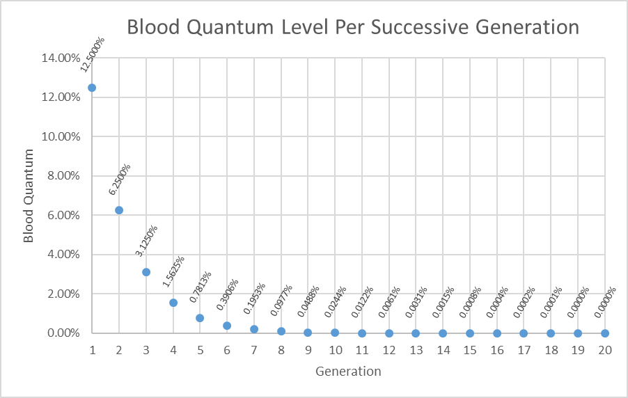

ACTIVITY #4 – Native Population Future

Create a math formula that results in this graph.

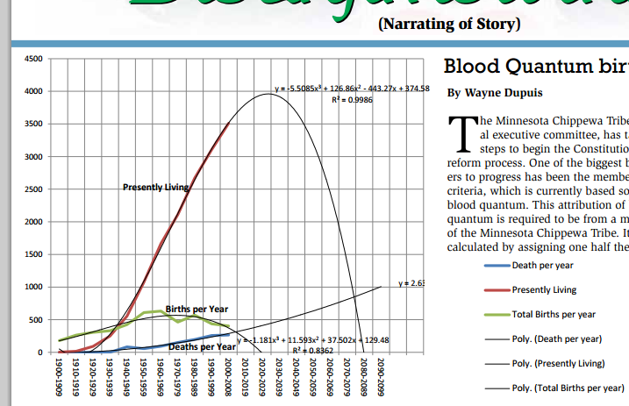

SOLUTION: Students can approximate the “Presently Living” graph by finding points from the red graph and performing regression on those ordered pairs. There are a variety of digitizer programs available to use, many are online and free. These can be used to try to get data as precise as possible. Most students, however, would probably just estimate the ordered pairs from the red graph. The solution in this key uses one ordered pair from each decade (as Census data is reported every ten years). The following estimates begin in the year 1920 and continue through the year 2000.

Year | Population
1920 | 80
1930 | 200
1940 | 480
1950 | 800
1960 | 1375
1970 | 1875
1980 | 2400
1990 | 2875
2000 | 3275

Judging by the behavior of the left side of the red graph, it doesn’t appear that quadratic is the best representation. Using a TI-84 calculator, both cubic and quartic regression result in R² values of approximately .9995 and .9996, respectively. The calculator graphs use the same window values as the original picture of the graph. The following screenshots represent cubic regression on the data.

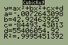
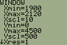
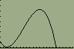
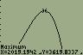

The following screenshots represent quartic regression on the data.

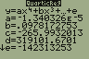
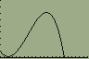
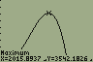

Both graphs are very close representations of the picture. The cubic regression graph’s local maximum value during the year 2019 seems to be a slightly better match than the quartic regression’s local maximum value, which is less, and in an earlier year (2015) than what appears to be shown in the picture of the graph.

In the magazine article, the picture includes an equation for the graph. The equation is

(with R² = 0.9986).

However, this equation adjusts the x-values (years) so that we begin at zero, and each ten year increment counts as just one unit. Graphing this equation on the calculator, and adjusting the window, we get the following results.

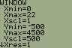
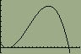
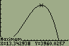

In any case, all graphs project that this tribe will reach a maximum enrollment slightly before the year 2020. The graphs also project that this tribe will reach an enrollment of zero sometime between the years of 2080 and 2090.

